**Assignment: 3**

**Experiments**

1. **Generate squares of all the integers from 1 to 50.**

**Coding:**

n1=int(input("Enter a 1st number"))  
n2=int(input("Enter a last number"))  
def printValues():  
 sqr = list()  
 for i in range(n1,n2):  
 sqr=(i*i)  
 print(sqr)  
printValues()

**Output:**

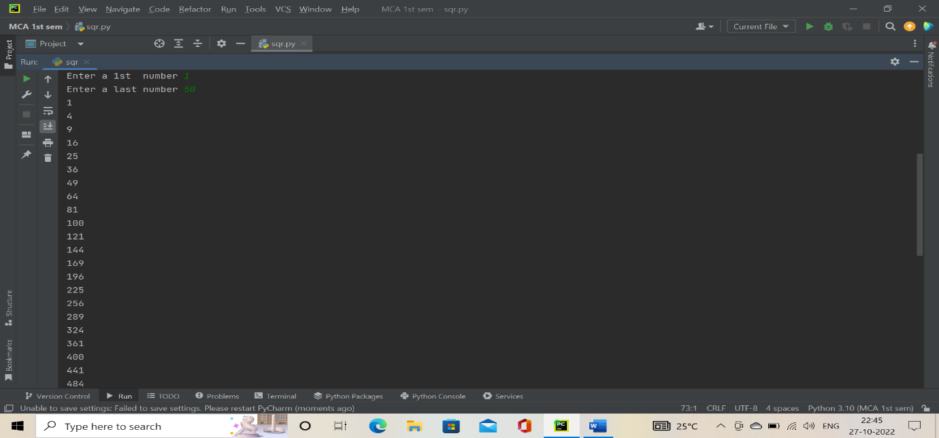

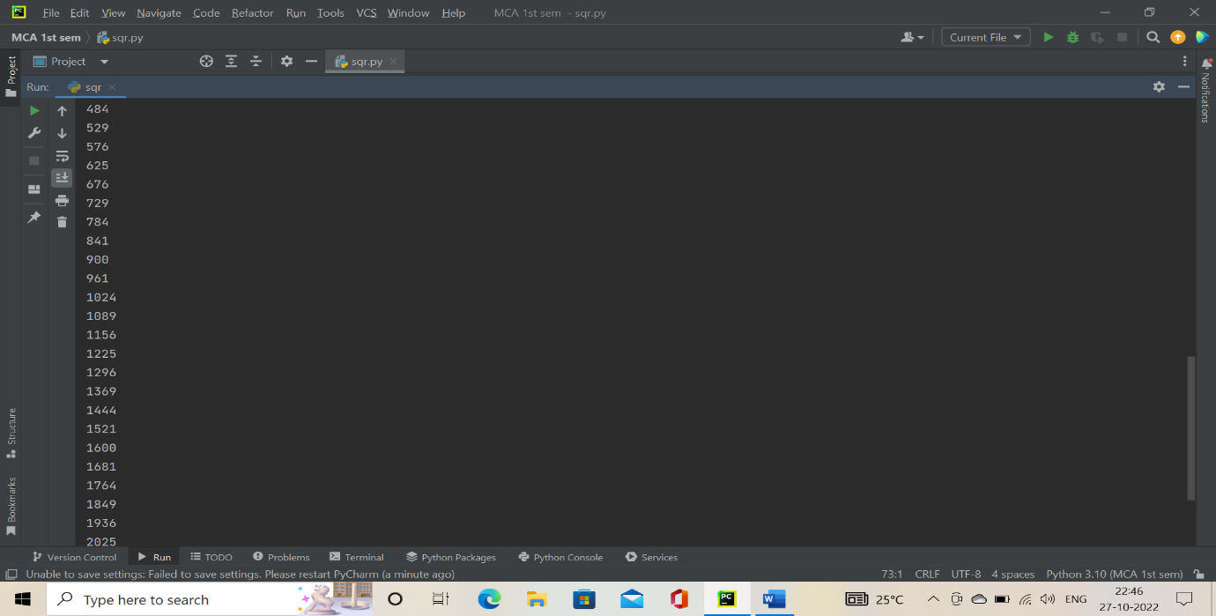

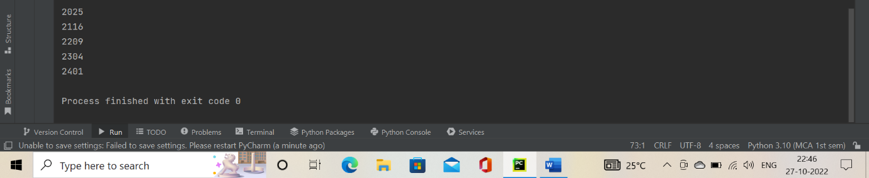

1. **Count the number of characters in a string using a loop.**

**Coding:**

string = input("enter a string value :")  
count = 0  
for i in range(0, len(string)):  
 if [(string[i] != ' ')]:  
 count = count + 1  
print("Total number of characters in a string: " + str(count))

**Output:**

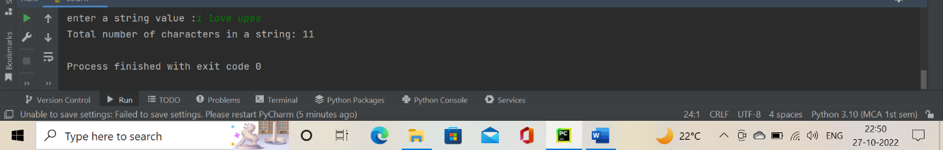

1. **Print a string in reverse.**

**Coding:**

def reverse(string):  
 string = string[::-1]  
 return string  
s=input("Enter a string: ")  
print("The original string is : ", end="")  
print(s)  
print("The reversed string is : ", end="")  
print(reverse(s))

**Output:**

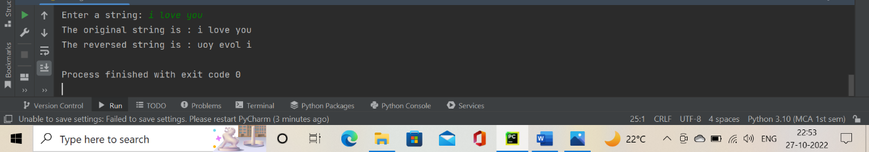

1. **Find all the prime numbers below 50.**

**Coding:**

a=int(input("enter a number: "))  
b=int(input("enter another number: "))  
print("prime number between",a,b)  
for num in range (a,b+1):  
 if num>1:  
 for i in range (2,num):  
 if (num%i==0):  
 break  
 else:  
 print(num)  
 break

**Output:**

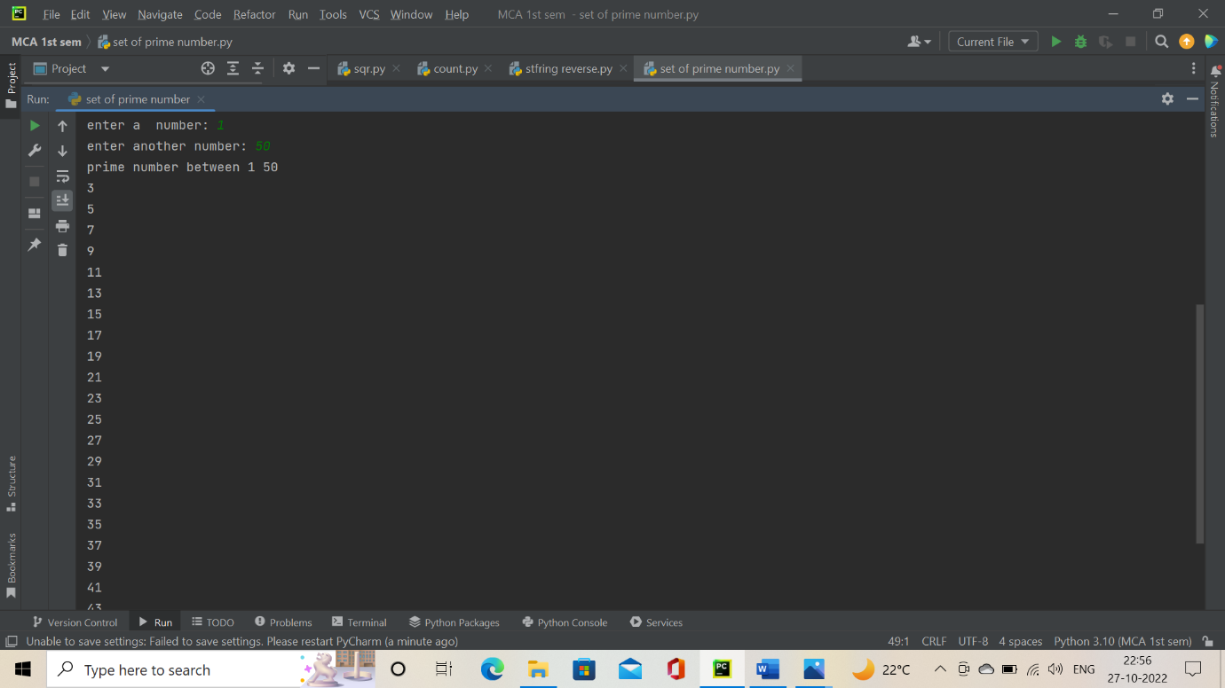

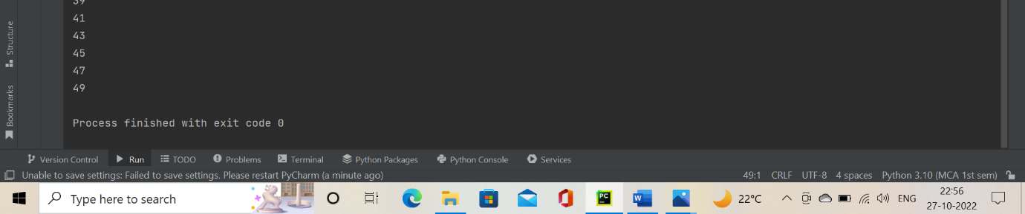

1. **Sum all the multiple integers of 5 below 50.**

**Coding:**

n1=int(input("Enter a 1st number"))  
n2=int(input("Enter a last number"))  
n = 0  
for i in range(n1,n2):  
 if not i % 5:  
 n = n + i  
print(n)

**Output:**

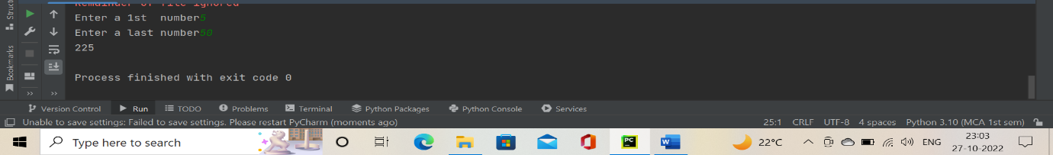

1. **Generate the patterns given below:**

|  |  |  |
| --- | --- | --- |
| **\***  **\* \***  **\* * * \***  **\* * * * \*** | **1**  **2 1 2**  **3 2 1 2 3**  **4 3 2 1 2 3 4** | **1 2 3 4 5**  **2 3 4 5**  **3 4 5**  **4 5**  **5** |
|  |  |  |

**Coding:**

n=int(input("enter a number"))  
i = 1  
j = 0  
while (i <= n):  
 while (j <= i - 1):  
 print("* ", end="")  
 j += 1  
 print("\r")  
 j = 0;  
 i += 1

**Output:**

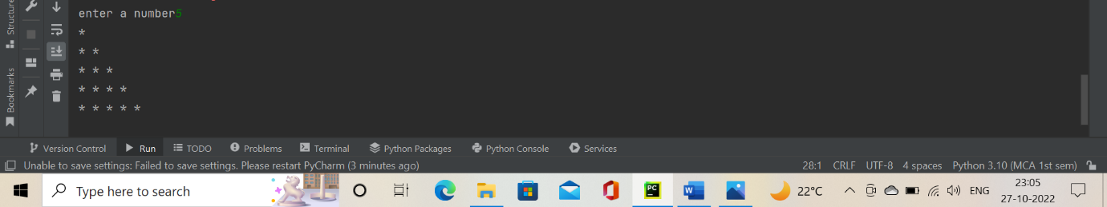 **Coding:**

rows = int(input("Enter the number of rows : "))  
print("\n")  
i = 1  
for i in range(i, rows+1):  
 j = i  
 for space in range(rows-i, -1, -1):  
 print(end=" ")  
 for j in range(j, 0, -1):  
 print(j,end="")  
 for j in range(j+1, i+1):  
 print(j,end="")  
 print("\n")

**Output:**

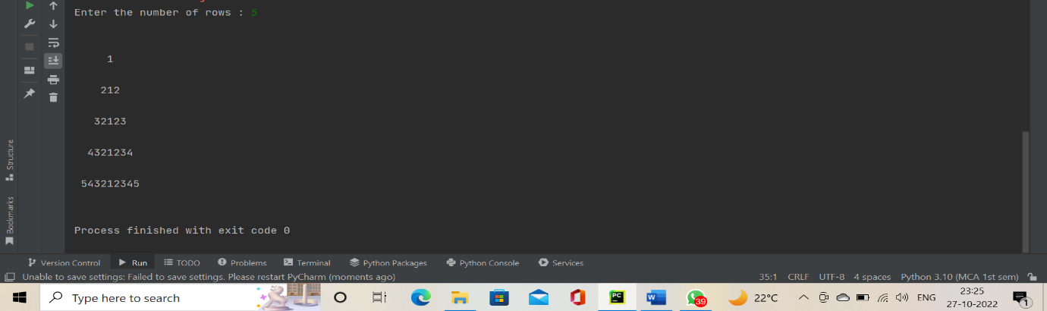

**Coding:**

j=int(input("enter a start number"))  
n=int(input("enter a end number"))  
while j<=n:  
 for i in range (j,n):  
 print(i,end=" ")  
 j=j+1  
 print("\n")  
 for k in range(1,j):  
 print(" ",end=" ")

**Output:**

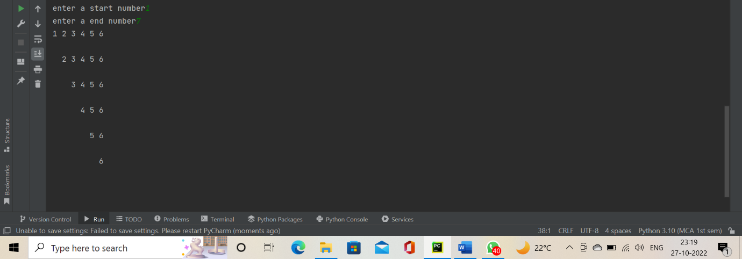

1. **Print Armstrong numbers in the range 1 to 1000. An Armstrong number is a number whose sum of the cubes of the digits is equal to the number itself.**

**For example, 370 = 33+73+03.**

**Coding:**

num = int(input("Enter a number: "))  
sum = 0  
temp = num  
while temp > 0:  
 digit = temp % 10  
 sum += digit ** 3  
 temp //= 10  
if num == sum:  
 print(num,"is an Armstrong number")  
else:  
 print(num,"is not an Armstrong number")

**Output:**

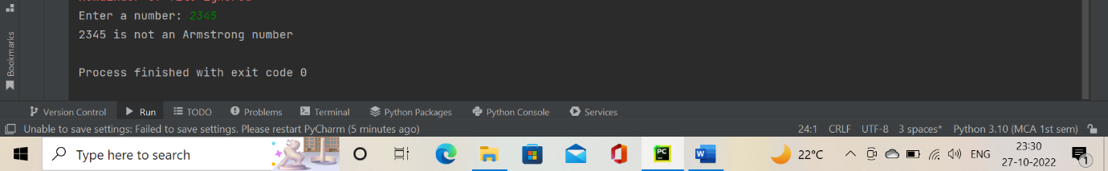

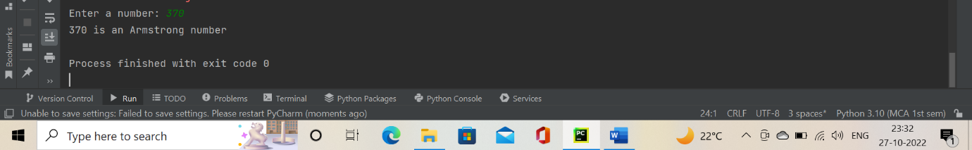

1. **Create an employee database having record for 5-10 employees in it. The attributes for an employee record are his/her name, age, salary, address. Take inputs from the user.**
2. **Print each record on a separate line**
3. **Update a record with given name.**

**Coding:**

n=int(input("enter a employees count number"))  
a_dict = {}  
for i in range (1,n):  
 name=input("Please enter en employee name : ")  
 print(" NOW ENTER AGE SALARY and ADDRESS : ")  
 a_dict[name] = input()  
for key, value in a_dict.items():  
 print(key, ' : ', value)  
print("HOW MANY MORE EMPLOYEE YOU WANT TO ADD :")  
choice=int(input())  
if(choice==1):  
 for i in range(0,choice):  
 name=input("Please enter an employee name : ")  
 print(" NOW ENTER AGE SALARY and ADDRESS : ")  
 a_dict[name] = input()  
for key, value in a_dict.items():  
 print(key, ' : ', value)

**Output:**

